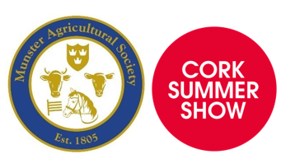
Munster Agricultural Society (MAS) home of Cork Summer Show

Office: Curraheen Road, Bishopstown, Cork. Phone: 021-4801919
VOLUNTEER APPLICATION FORM 2025

- Name: __________________________________ 2. Mobile/s___________________________________

Address & Eircode: __________________________________________________________________________

Email___________________________________ 5. Date of birth: ______________________________

6. Do you know any current members of Munster Agricultural Society? _______________________________

If yes, please provide their name(s): _______________________________________________________

- Do you have an area of volunteering interest?

- Confirm your volunteering availability:
 | Yes | No
MAS Ag Canine events (w/e in 26/27 July)

Weekdays in the MAS Office in advance of the Cork Summer Show

Friday 13th before Cork Summer Show

Saturday 14th during Cork Summer Show

Sunday 15th during Cork Summer Show

Have you volunteered before? ________________ If yes, please provide details about your previous experience

Signature (1) ______________________________ Signature (2) ________________________

Dated: _________________________________

