Meeting of the Show Committee held on Saturday, 21st May, 1932. The President Capt. T.A. Clarke in the chair, also present Prof. Boyle, Messrs. T. O’Sullivan, E.J. Clarke, W. Roberts, J. Daly, V.S., D. Ross, A.H. Moore, W. Desmond, T.D., A. Morrison, Hon. Secretary.

The minutes of the last meeting were read & signed.
A letter was read from the McGillycuddy, regretting he could not accept the Committee’s invitation to judge Kerries at the forthcoming Summer Show, and he the Secretary, then wrote Major Phelps ,Hon. Secretary ,Kerry Cattle Society ,asking him for the names of some judges for this breed. Mr. E. McLysaght, who answered on behalf of Mr. Phelps, stated he would suggest Mr. R. Lynch of the Department of Agriculture. The Secretary stated that he took it on himself to write Mr. Lynch ,but had not as yet, received a reply from him. The Secretary’s action was approved of.
In connection with the erection of Band Stands in the Show ,it was decided, on the motion of Capt. Clarke, seconded by Mr. T. O’Sullivan, to leave the matter in the hands of Mr. E.J. Clarke and the Secretary.
It was agreed that a meeting of the Show Committee be held in the Committee Room on the Show Grounds on Saturday, 28th inst.
T.A. Clarke
28-5-32
Meeting of the Dog Show Committee held on Monday, 23rd May, 1932, Mr. L. Dobbin in the chair, also present Mrs. Fielding ,Dr. A.F.M. Mullane, and Mr. A.H. Shortt.
The minutes of the last meeting were read & signed.
The Committee was engaged for a considerable time in going through the classification for the forthcoming show, which they decided should be forwarded to the Kennel Club at once for approval. The question of classes for Alsatians was left in the hands of Mr. Dobbin and the Secretary , and the classification for Cairn Terries was left over until The Secretary had seen Miss Patten re same. It was agreed, on the motion of Mr. Shortt, seconded by Dr. Mullane, that Mrs. Fielding and Mrs. O’Connor Judge the Children’s cases.
L. Dobbin
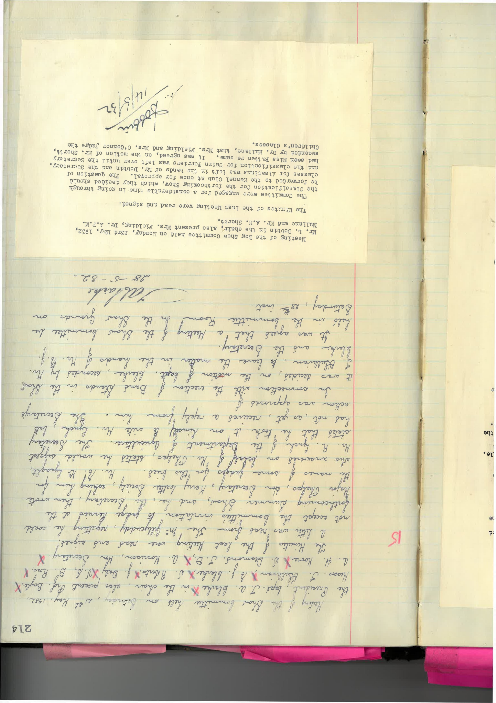
14.6.32

